Early Warning and Reporting System (EWARS)- Weekly Bulletin: Nepal
^{48th} Epidemiological Week, 2023
Sunday, 10th December, 2023
Highlights
- 1003442 cases of Corona Virus disease (COVID-19) have been confirmed in Nepal, of which 991350 cases have been recovered so far.  - Of the reported cases, Dengue is the leading cause of morbidity in week 48. | Number of cases reported for each disease this week  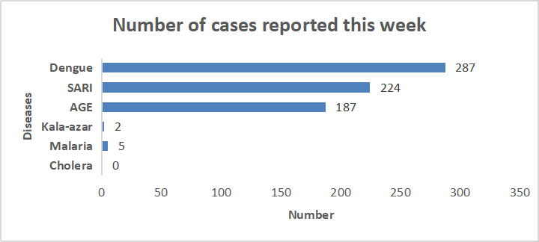
Note: This bulletin includes data since January 2021 till date, including comparison of the same period last two year. Since, May 2019, 36 new sentinel sites (including public hospitals, private hospitals, and medical colleges) were added and was gradually oriented and started reporting, thus increasing the number of reporting sites. The current number of sentinel sites is 118.
- Acute Gastro-Enteritis (AGE)

- 187 cases of AGE were reported this week. Most of these cases were reported from Parsa (21 case), ,Kathmandu (13 case ),Saptari ( 11 case), Kapilbastu and Rautahat ( 9 case from each district) and Dhanusha (8 case).
- 158 cases of AGE were reported this week in 2022.

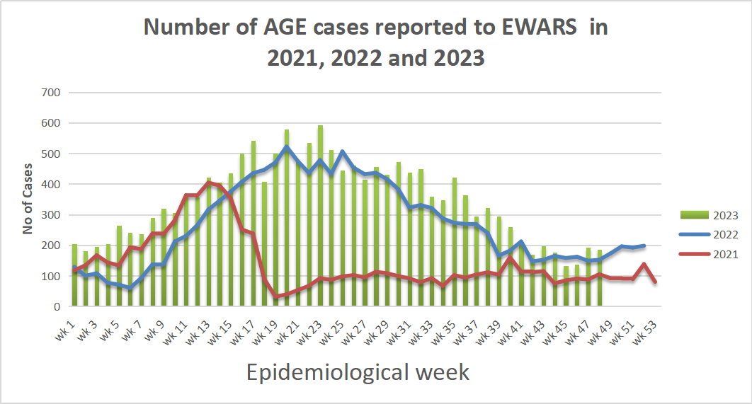

- Severe Acute Respiratory Infection (SARI)
- 224 cases of SARI were reported this week. Most of these cases were reported from Morang (24 case), , Kathmandu ( 16 case) and Parsa (15 case), Sunsari (13 case), Rupandehi and Saptari ( 11 case from each district).
- 316 cases of SARI were reported this week in 2022.

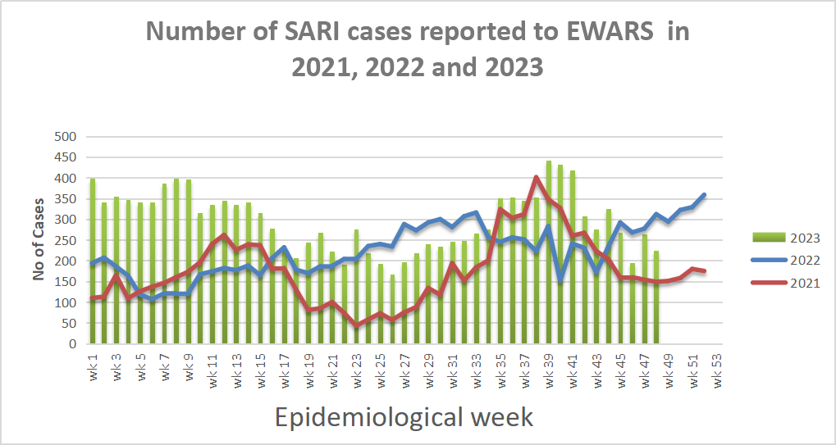
- Malaria
- Five cases of Malaria were reported this week. Of them, two cases of malaria falciparum were were reported from Kailali and Doti and three case of malaria vivax were from Surkhet, Palpa and Nawalparasi East.
- Three cases of Malaria were reported this week in 2022.

- Kala-azar

- Two cases of Kala-azar were reported this week. They were from Kalikot and Mahottari.
- Seven cases of Kala-azar were reported this week in 2022.

- Cholera

- No case of Cholera was reported this week.
- Zero case of Cholera was reported this week in 2022.

- Dengue
- 287 cases of Dengue were reported this week. Most of these cases were reported from Kaski (49 case), Jhapa (29 case), Kathmandu (26 case), Chitawan (25 case), and Bhaktapur (16 case).
- 220 cases of Dengue were reported this week in 2022.

Other diseases
Scrub typhus
- 66 case of Scrub Typhus were reported this week. Of them, most of the cases were reported from Bardia (11 case), Sankhuwasabha (10 case ), Kailali ( 7 case ), Tanahu (6 case), and Banke( 4 case).
- 56 cases of Scrub Typhus were reported this week in 2022.
SHAPU: Three cases of SHAPU were reported this week. All of them were from Kathmandu.
Table: Comparison with previous week by diseases, 2023
Diseases | Week 48 | Week 47
AGE | 188 | 208
SARI | 225 | 272
Malaria | 5 | 3
Kala-azar | 2 | 2
Dengue | 287 | 378
Cholera | 0 | 1

Province wise reporting status:
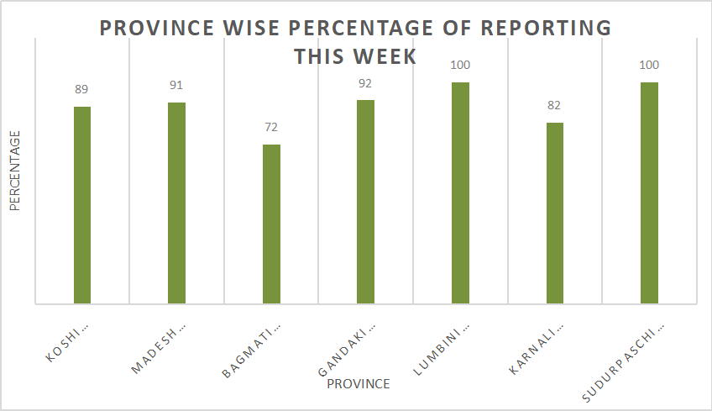
National Reporting Status (%):

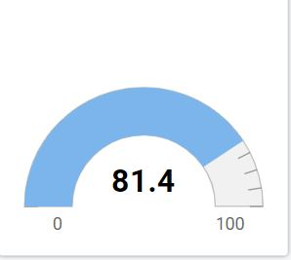

Acknowledgement: The Epidemiology and Disease Control Division (EDCD) highly acknowledges the contribution from all the sentinel sites, medical recorders, EWARS focal persons, rapid response team members and technical support from WHO and GIZ for preparation of this bulletin.

Note: This bulletin is also available at the EDCD website (please click here). Other information can also be accessed at the website www.edcd.gov.np. Thank you.
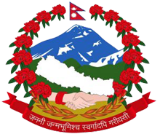

Government of Nepal
Ministry of Health and Population
Department of Health Services
Epidemiology and Disease Control Division
Kathmandu, Nepal

